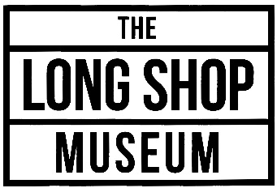
Traders Application Form
The Long Shop Museum, 2018 season
Long Shop Museum, Main Street, Leiston, Suffolk, IP16 4ES. Tel 01728 832189
Please complete form in CAPITALS thank you. Museum contact: events@longshopmuseum.co.uk

I wish to enter for the following events, (you can enter more than one event, please tick);
Steam Up, 1st April 2018
Works in Wartime, 21st April 2018
Father’s Day Model Show, 17th June 2018
Suffolk Steam Punk Spectacular, 28th &29th July
Harvest Past, 23rd September 2018
Final Fling, 21st October 2018

YOUR NAME ________________________________________________________________
TRADE NAME ________________________________________________________________
TYPE OF ITEMS SOLD ________________________________________________________________
ADDRESS ______________________________________________________________________
______________________________________________________________________
E-MAIL (required for booking confirmation) __________________________________________________________
PHONE NUMBER ____________________ MOBILE NUMBER ______________________

PLEASE NOTE THAT THE FOLLOWING PRICES ARE PER EVENT, IF YOU ARE BOOKING FOR MORE THAN ONE EVENT, THEN PLEASE INCLUDE PAYMENT TO COVER ALL BOOKINGS.

INSIDE AREA
Please reserve for me _____inside pitch @ £30 each
Please note; 1 pitch = 1 table length, no more than 7 ft long. Multiple pitches per event can be booked.

Note an electrical supply may be available if requested in advance. Set up is from 08:30 on the day of the event, alternatively, you may set up from 3pm on the day before each event.

OUTSIDE AREA

Please reserve for me _____outside pitch @ £20 each

We can supply a 6ft x 2/3ft table only if required and each table will have a chair. Note you may erect a gazebo (maximum of 3m x 3m, larger gazebos by prior arrangement) There is no refund for inclement weather.
Set up is from 08:30am on the day of the event.
Please note that outside stalls cannot be left up overnight.

NOTE – please indicate your stall requirements here and we will try to accommodate them
Electrical supply (inside only and subject to availability) Yes/No
Table required, 1 per pitch (6ft x 2/3ft) Yes/No
Additional chairs Yes/No Amount…………
Other – please state

ELECTRONIC PAYMENT
Please complete a BACS Payment to:
The Long Shop Museum, Sort Code 20-45-45 Account No.13786447
Reference LSM plus your name

Please return the completed booking form to;

Stuart Hines
The Long Shop Museum
Main Street
Leiston
Suffolk
IP16 4ES

Or events@longshopmuseum.co.uk

FORM PAYMENT
Make a cheque payable to: The Long Shop Museum and post along with the completed form to
Event Booking, Long Shop Museum, Main Street, Leiston, Suffolk, IP16 4ES

SIGNED _________________________________________ DATED ___________________

Confirmation of bookings will be sent out at least 2 weeks prior to the event.

The Long Shop Project Trust is a Registered Charity No. 1167945 VAT No. 699 9327 49

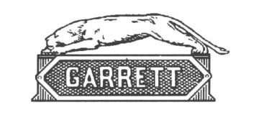
Please return this form together with a SAE to, Long Shop Museum, Main Street, Leiston, IP164ES
The Long Shop Project Trust. A Registered Charity No. 283444. VAT No. 699 9327 49
Trustees: The Earl of Cranbrook, T.J. Hawkins, J.D.B.Cotton, W.J. Kemball, A.M.I. Paris, R.H.G.Watson, Mrs M. Young. Hon. Treasurer: K.S. Young. Hon. Secretary: Mrs. M. Wyllie.
Patrons: J.R.G. Perrett, W.R. Serjeant, R.A. Wilton
Federated with the Museum of East Anglian Life

